VECar

An Virtual Environment Car driving training system

Yanxiang Wu, Evan Gaito

# Goal and motivation

Car driving learning in some country is quite expensive and intimating for many people, our VECar driving training system help people to learn and practice driving in an immersive and instructive way.

# Key Features

Immersive:

* About 170 degree horizontal Field of View.
* Essential car driving parameter feedback in the Virtual Environment (Speed, rear-view mirror, side-view mirror)

Interaction:

* Instruments for use to perform 3 specific tasks
  + Normal driving
    - Detect whether user stopped when see stop sign
    - Detect whether user drive out of boundary
  + Normal Parking
    - Detect whether user collide with curb and obstacles when parking
  + Parallel Parking
    - Simulate typical situation for parallel parking ( a car in side and 3 enclosed obstacles)

Evaluation:

* Provide user with feedback when they do wrong thing
* Provide user a score to evaluate their feedback
  + Detail feedback showed up when specific event happened

# Project Progress Overview

The project is managed in github. All the progress can be tracked by link: <https://github.com/cecilulysess/VECar/graphs/contributors>

Here is the statistic of the project:

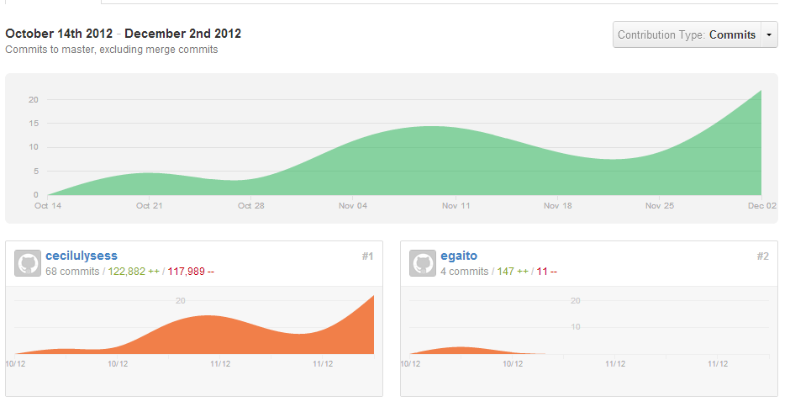

# Contributions

## Yanxiang Wu

1. Modeling all the test course, road, obstacles
2. Added collision interaction of all the obstacles, boundaries.
3. Collected car behavior and DMV course information
4. Implemented the car physically motion model and tuning it so that it works with steering wheels.
5. Created instruction system for the user
6. Created the feedback system for the user’s behavior
7. Created the scoring system for the user.

## Evan Gaito

1. Created simple car model
2. Collect car data
3. Created and continued to modify car engine script
4. Integrated simulation with steering wheel/pedals controller
5. Implemented realistic reversing
6. Add some colliders to car and testing course
7. Create models of barrier and cones
8. Testing